<?xml version="1.0" encoding="UTF-8"?>

<xsl:stylesheet version="1.0"

xmlns:xsl="http://www.w3.org/1999/XSL/Transform">

<xsl:template match="/">

<html>

<body>

<h1 align="center">Students' Basic Details</h1>

<table border="3" align="center" >

<tr>

<th>Name</th>

<th>Branch</th>

<th>Age</th>

<th>City</th>

</tr>

<xsl:for-each select="student/s">

<tr>

<td><xsl:value-of select="name"/></td>

<td><xsl:value-of select="branch"/></td>

<td><xsl:value-of select="age"/></td>

<td><xsl:value-of select="city"/></td>

</tr>

</xsl:for-each>

</table>

</body>

</html>

</xsl:template>

</xsl:stylesheet>

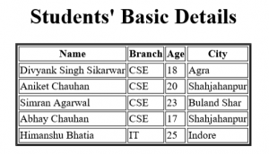

<!DOCTYPE student [  
  
<!ELEMENT student (s+)>  
<!ELEMENT Name (HEADLINE,BYLINE,LEAD,BODY,NOTES)>  
<!ELEMENT Branch (#PCDATA)>  
<!ELEMENT City (#PCDATA)>  
<!ELEMENT Age (#PCDATA)>  
]>

Xsd:

<xs:element name="student">  
  <xs:complexType>  
    <xs:sequence>  
      <xs:element name="Name" type="xs:string"/>  
      <xs:element name="Branch" type="xs:string"/>  
      <xs:element name="City" type="xs:string"/>  
      <xs:element name="Age" type="xs:string"/>  
    </xs:sequence>  
  </xs:complexType>  
</xs:element>